1. In the previous lecture, we learnt basic of a component. Let’s play with AppComponent a bit.
2. 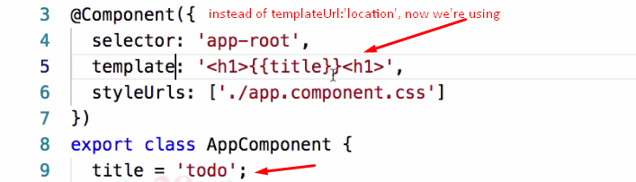
3. 